Date : | 1 May 2012
Test Environment : | http://johnpc7.emerging.com.au/ehs/ehsDADAServlet
Browser and Version : | ie8
Screen : | Discharge Summary
Build : | 2.9.15.31
Helpdesk Reference : | 77048ESSQL001
Reported By : | John

Problem Description:

NOK data not transferring to NEW Discharge Summary

Comment :

Replication Steps :
- Select a discharged patient with next of kin details but with no NEW Discharge Summary:
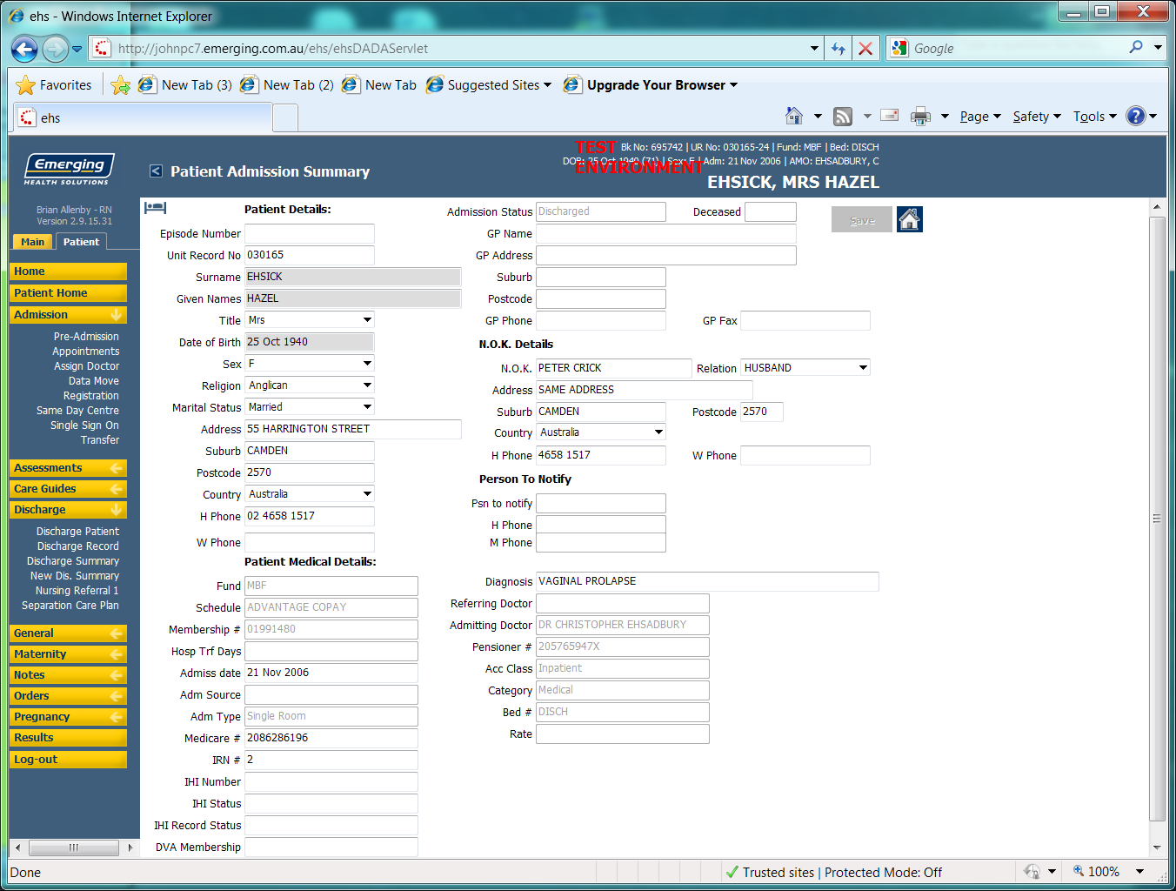
- Create a NEW Discharge Summary: 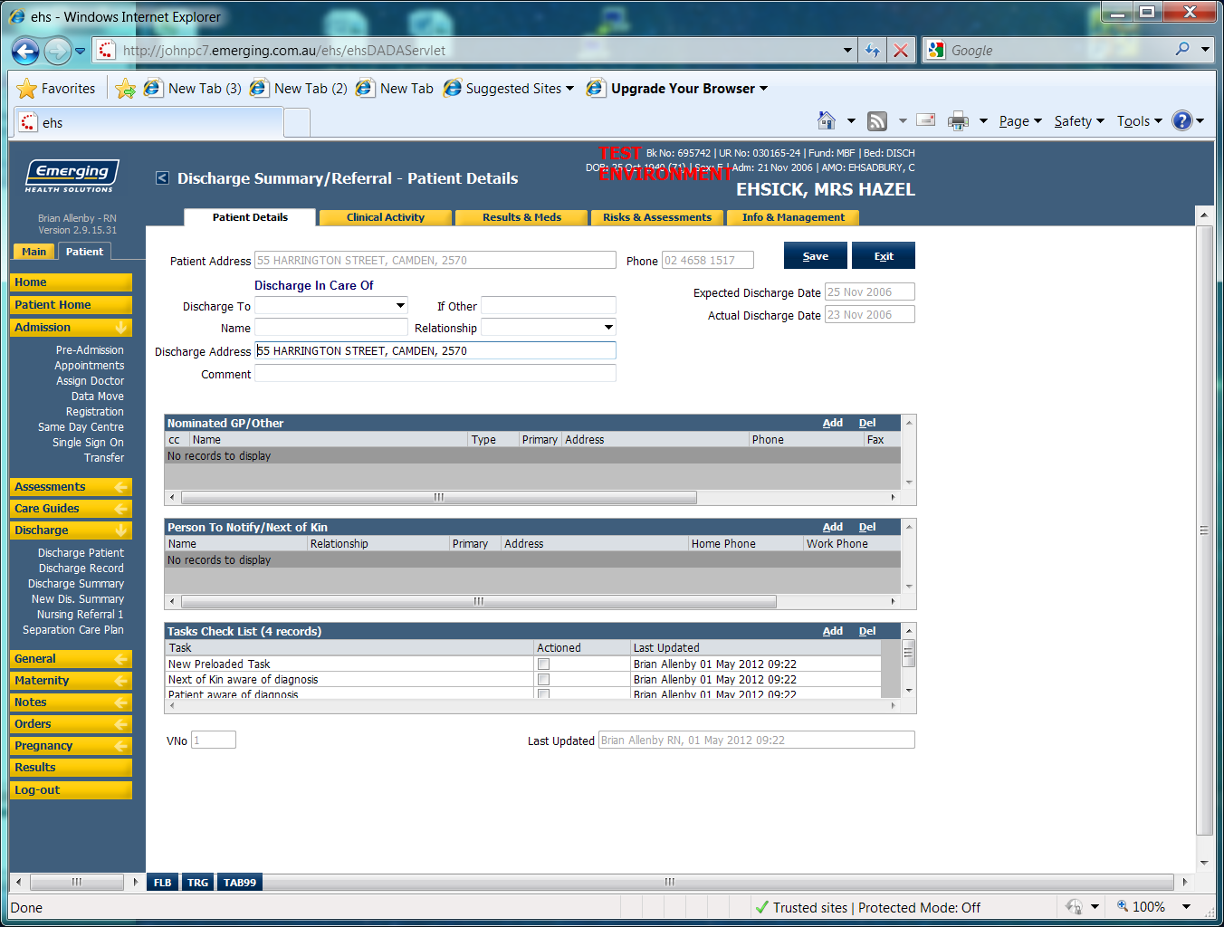
- No Next of kin data loaded!!

- View Discharge Summary: 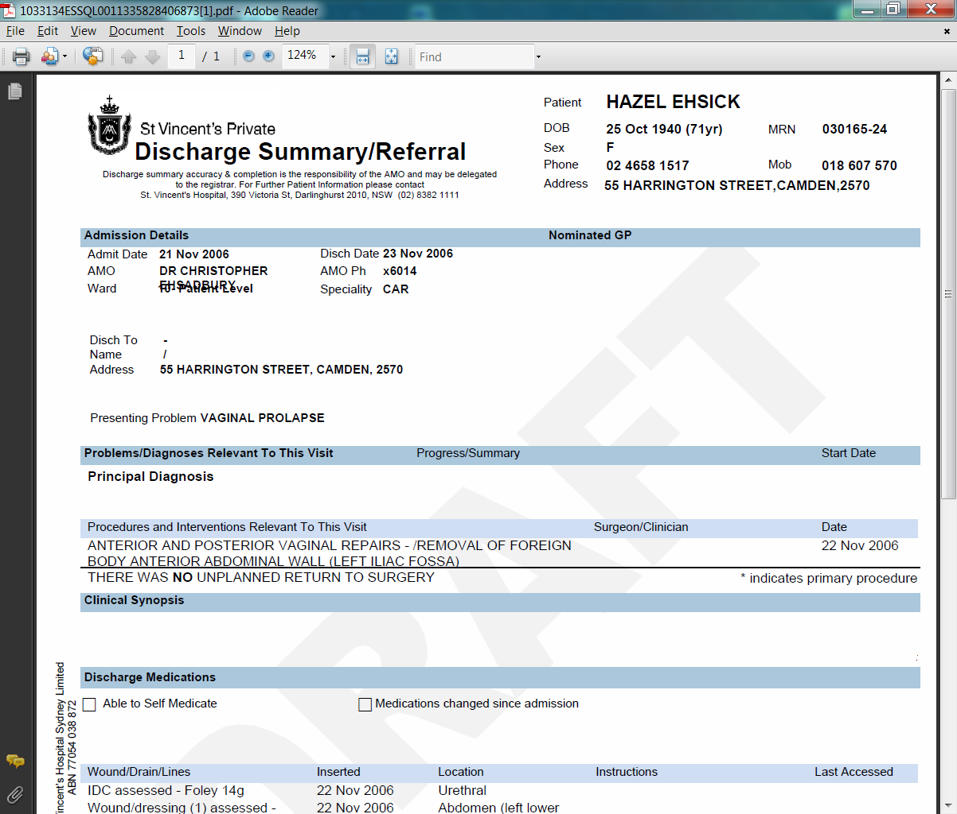

- There is NO Next of Kin Data

